Isosceles Triangle Theorem

Definition
# Source: AI Source: Provided by: [Data Path: Persons Table -> ID Column: 1, Name_En Column: Motasem Essam] -> From: [ChatGPT] on [7/25/2026]
The Isosceles Triangle Theorem states that if two sides of a triangle are equal in length, then the angles opposite those equal sides are also equal.
For an isosceles triangle $ABC$, if:
$$\boxed{AB=AC}$$
then the opposite base angles are equal:
$$\boxed{∠B=∠C}$$
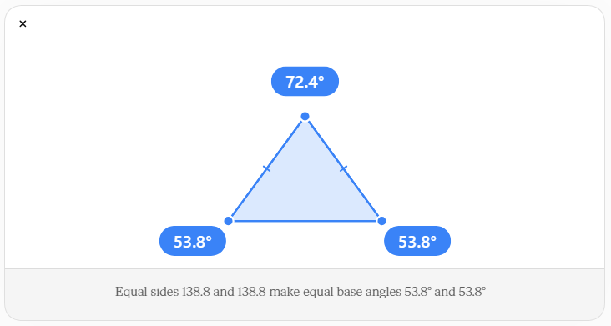
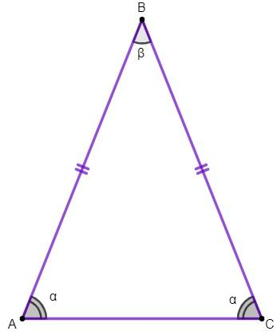
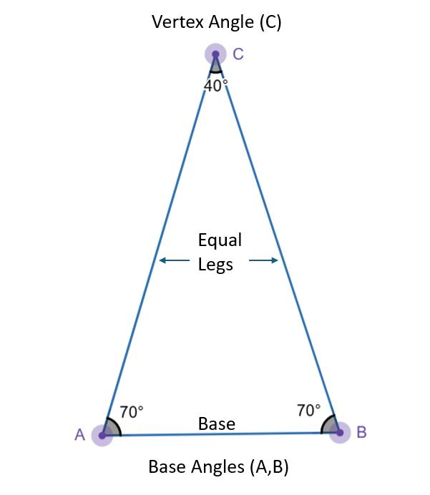
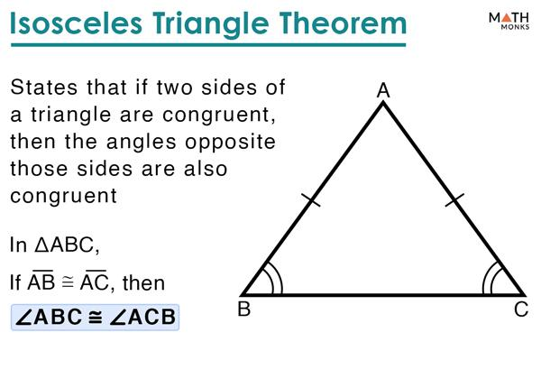
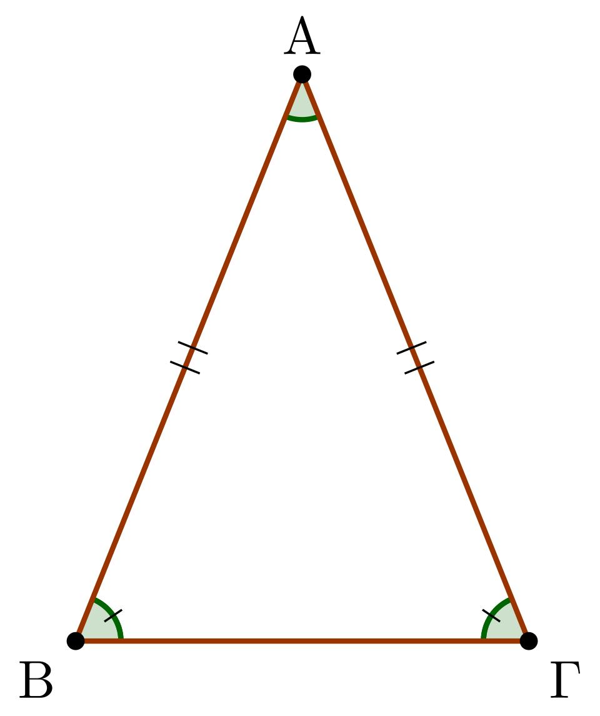
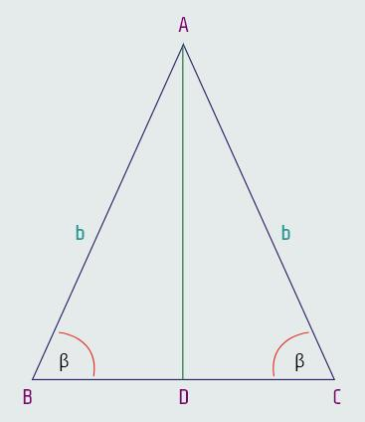
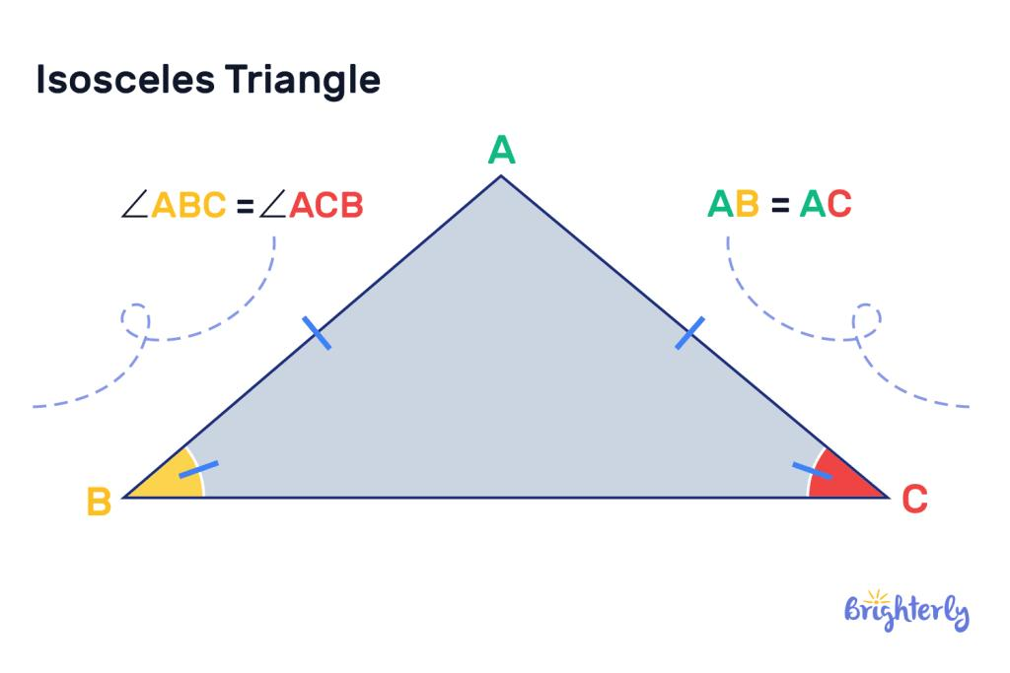

Purpose
# Source: AI Source: Provided by: [Data Path: Persons Table -> ID Column: 1, Name_En Column: Motasem Essam] -> From: [ChatGPT] on [7/25/2026]
The Isosceles Triangle Theorem is used to:
- Identify equal angles in an isosceles triangle.
- Find unknown angle measures.
- Prove that two angles are congruent.
- Solve triangle geometry problems.
- Support geometric proofs.
- Establish relationships between sides and angles.

Basic Configuration
# Source: AI Source: Provided by: [Data Path: Persons Table -> ID Column: 1, Name_En Column: Motasem Essam] -> From: [ChatGPT] on [7/25/2026]
Consider triangle $ABC$.
Suppose:
$$AB=AC$$
Therefore, $ABC$ is an isosceles triangle.
The side $BC$ is called the base, and the equal sides $AB$ and $AC$ are called the legs.
The angles opposite the equal sides are:
$$∠C$$
opposite $AB$, and:
$$∠B$$
opposite $AC$.
Therefore:
$$\boxed{∠B=∠C}$$

Mathematical Representation
# Source: AI Source: Provided by: [Data Path: Persons Table -> ID Column: 1, Name_En Column: Motasem Essam] -> From: [ChatGPT] on [7/25/2026]
The theorem can be written as:
$$\boxed{AB=AC⇒∠B=∠C}$$
More generally:
$$\boxed{\text{Equal sides}⇒\text{Equal opposite angles}}$$

Example 1 — Finding an Unknown Angle
# Source: AI Source: Provided by: [Data Path: Persons Table -> ID Column: 1, Name_En Column: Motasem Essam] -> From: [ChatGPT] on [7/25/2026]
Suppose:
$$AB=AC$$
and:
$$∠B={50}^{∘}$$
According to the Isosceles Triangle Theorem:
$$∠B=∠C$$
Therefore:
$$\boxed{∠C={50}^{∘}}$$
Using the Triangle Angle Sum Theorem:
$$A+B+C={180}^{∘} \\ A+{50}^{∘}+{50}^{∘}={180}^{∘}$$
Therefore:
$$\boxed{∠A={80}^{∘}}$$

Example 2 — Finding the Base Angles
# Source: AI Source: Provided by: [Data Path: Persons Table -> ID Column: 1, Name_En Column: Motasem Essam] -> From: [ChatGPT] on [7/25/2026]
Suppose the vertex angle is:
$$∠A={40}^{∘}$$
and:
$$AB=AC$$
Because the base angles are equal:
$$∠B=∠C$$
Using:
$$A+B+C={180}^{∘}$$
we get:
$${40}^{∘}+B+C={180}^{∘}$$
Since:
$$B=C$$
we can write:
$${40}^{∘}+2B={180}^{∘} \\ 2B={140}^{∘} \\ \boxed{B=C={70}^{∘}}$$
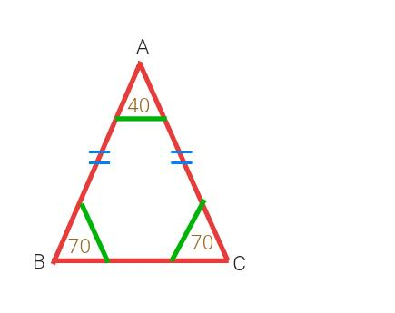
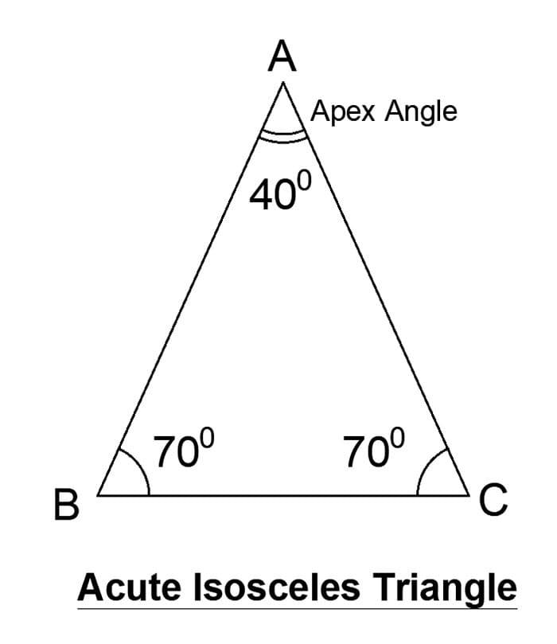
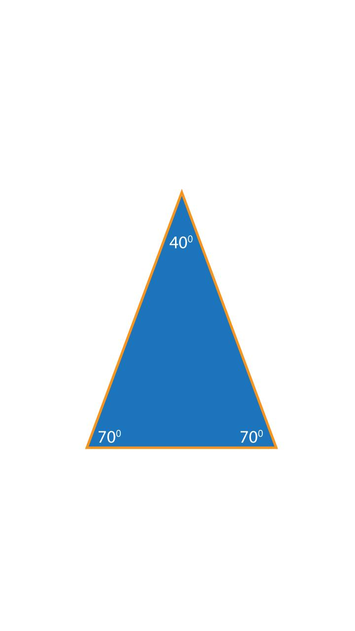

Converse of the Isosceles Triangle Theorem
# Source: AI Source: Provided by: [Data Path: Persons Table -> ID Column: 1, Name_En Column: Motasem Essam] -> From: [ChatGPT] on [7/25/2026]
There is also a converse.
If two angles of a triangle are equal, then the sides opposite those angles are equal.
For example, if:
$$\boxed{∠B=∠C}$$
then:
$$\boxed{AB=AC}$$
Therefore:
$$\boxed{\text{Equal angles}⇒\text{Equal opposite sides}}$$
This is called the Converse of the Isosceles Triangle Theorem.

Example of the Converse
# Source: AI Source: Provided by: [Data Path: Persons Table -> ID Column: 1, Name_En Column: Motasem Essam] -> From: [ChatGPT] on [7/25/2026]
Suppose:
$$∠B={65}^{∘}$$
and:
$$∠C={65}^{∘}$$
Since:
$$∠B=∠C$$
the opposite sides must be equal:
$$\boxed{AB=AC}$$
Therefore, triangle $ABC$ is isosceles.

Relationship Between Sides and Angles
# Source: AI Source: Provided by: [Data Path: Persons Table -> ID Column: 1, Name_En Column: Motasem Essam] -> From: [ChatGPT] on [7/25/2026]
The theorem illustrates an important general principle:
$$\boxed{\text{Equal sides have equal opposite angles}}$$
and conversely:
$$\boxed{\text{Equal angles have equal opposite sides}}$$
For an isosceles triangle:
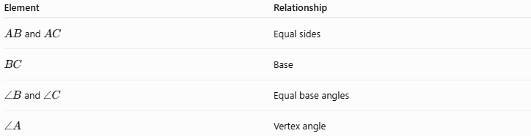
Element | Relationship
$AB$and $AC$ | Equal sides
$$BC$$ | Base
$∠B$ and $∠C$ | Equal base angles
$$∠A$$ | Vertex angle

Vertex Angle and Base Angles
# Source: AI Source: Provided by: [Data Path: Persons Table -> ID Column: 1, Name_En Column: Motasem Essam] -> From: [ChatGPT] on [7/25/2026]
An isosceles triangle has:
- Two equal sides.
- Two equal base angles.
- One vertex angle.
- One base.
If the vertex angle is $A$, then:
$$B=C$$
Since:
$$A+B+C={180}^{∘}$$
we have:
$$A+2B={180}^{∘}$$
Therefore:
$$\boxed{B=C=\frac{{180}^{∘}-A}{2}}$$

Special Case — Equilateral Triangle
# Source: AI Source: Provided by: [Data Path: Persons Table -> ID Column: 1, Name_En Column: Motasem Essam] -> From: [ChatGPT] on [7/25/2026]
An equilateral triangle has three equal sides:
$$AB=BC=CA$$
Therefore, all three angles are equal:
$$A=B=C$$
Since their sum is ${180}^{∘}$:
$$\boxed{A=B=C={60}^{∘}}$$
An equilateral triangle can therefore be considered a special case of an isosceles triangle under the definition of isosceles meaning at least two equal sides.

Relationship with the Triangle Angle Sum Theorem
# Source: AI Source: Provided by: [Data Path: Persons Table -> ID Column: 1, Name_En Column: Motasem Essam] -> From: [ChatGPT] on [7/25/2026]
The two theorems work together.
The Isosceles Triangle Theorem gives:
$$B=C$$
The Triangle Angle Sum Theorem gives:
$$A+B+C={180}^{∘}$$
Combining them:
$$A+2B={180}^{∘}$$
This makes it easy to find all angles when one angle is known.

Relationship with Triangle Classification
# Source: AI Source: Provided by: [Data Path: Persons Table -> ID Column: 1, Name_En Column: Motasem Essam] -> From: [ChatGPT] on [7/25/2026]
The Isosceles Triangle Theorem applies to triangles classified by their sides.
Equilateral
$$3\text{ equal sides}$$
and:
$$3\text{ equal angles}$$
Isosceles
$$2\text{ equal sides}$$
and:
$$2\text{ equal base angles}$$
Scalene
$$3\text{ unequal sides}$$
and:
$$3\text{ unequal angles}$$

Proof of the Isosceles Triangle Theorem
# Source: AI Source: Provided by: [Data Path: Persons Table -> ID Column: 1, Name_En Column: Motasem Essam] -> From: [ChatGPT] on [7/25/2026]
Consider an isosceles triangle $ABC$ where:
$$AB=AC$$
Draw a line from $A$ to the midpoint $D$ of $BC$.
Then:
$$BD=DC$$
Also:
$$AB=AC$$
and:
$$AD=AD$$
because $AD$ is common to both triangles.
Therefore:
$$△ABD≅△ACD$$
by SSS congruence.
Corresponding angles are therefore equal:
$$\boxed{∠B=∠C}$$
Thus, the Isosceles Triangle Theorem is proved.
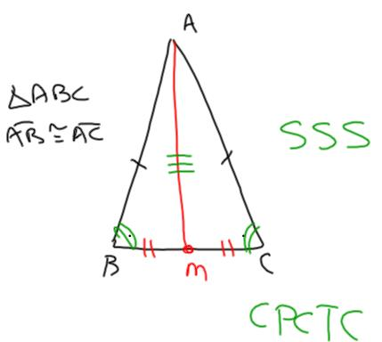
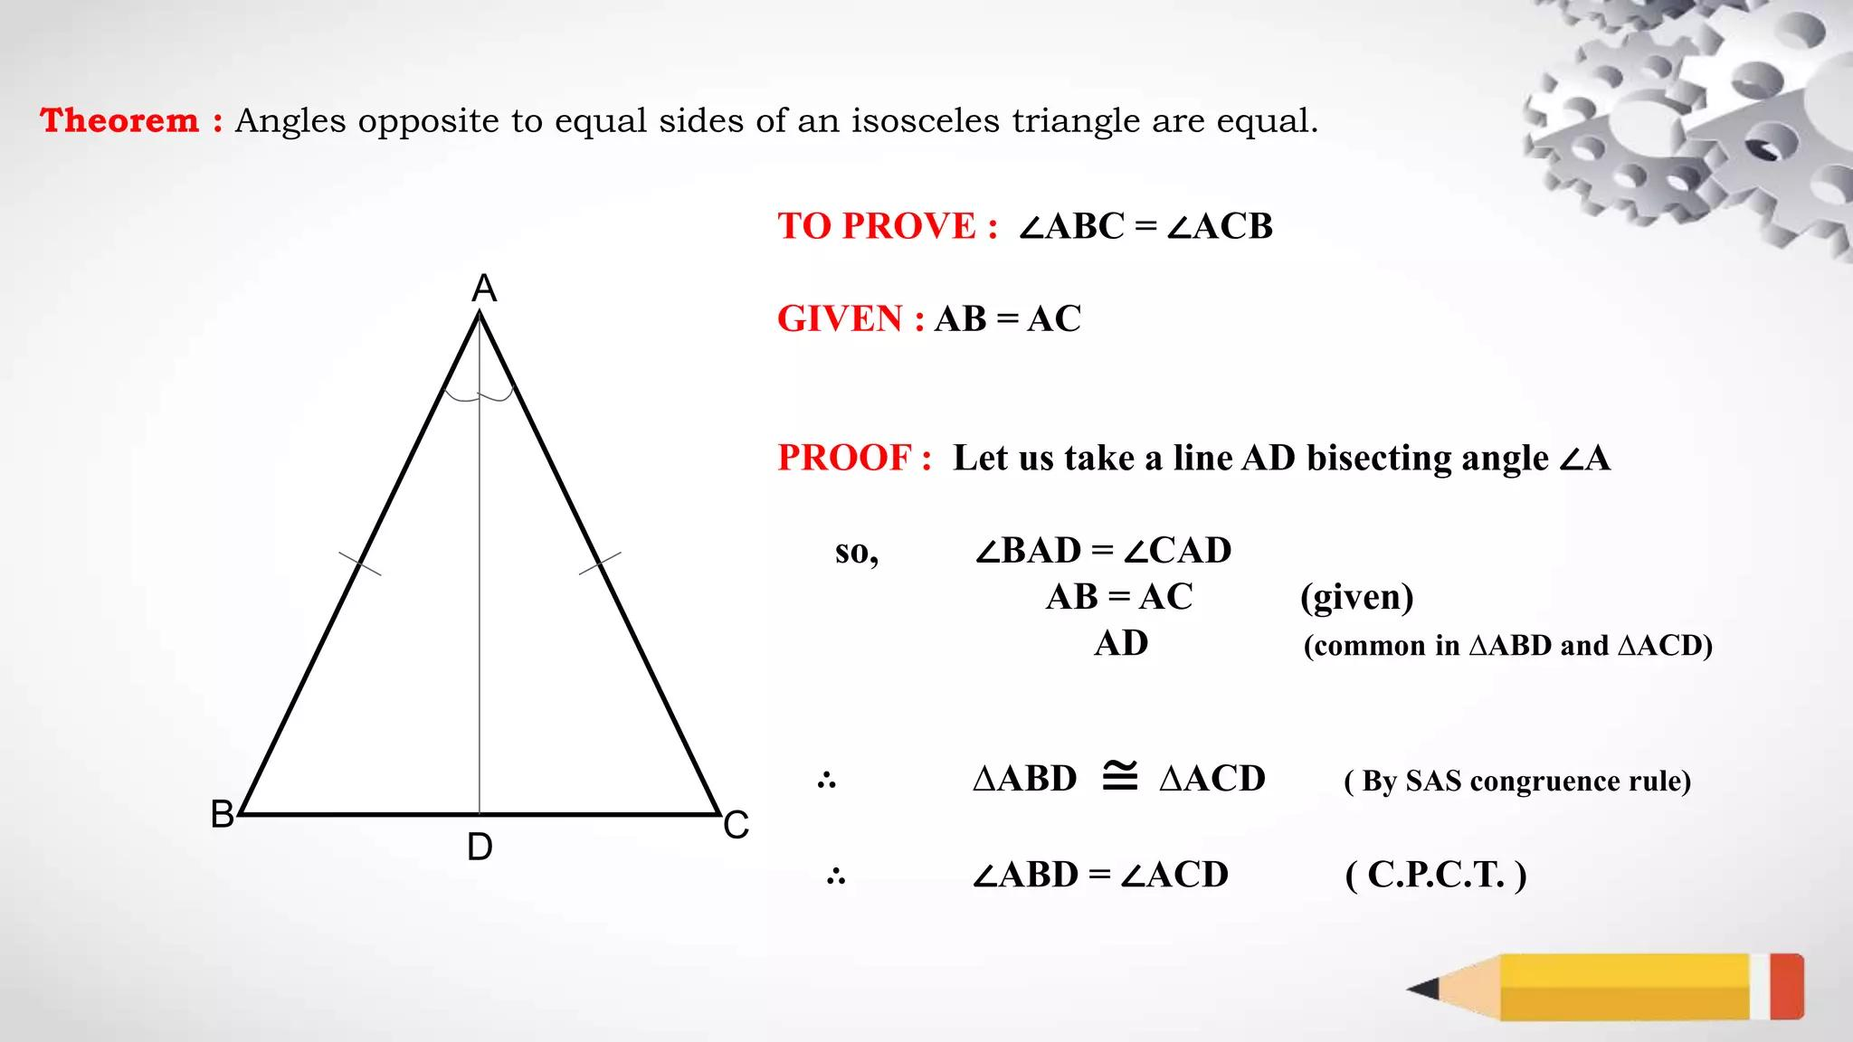
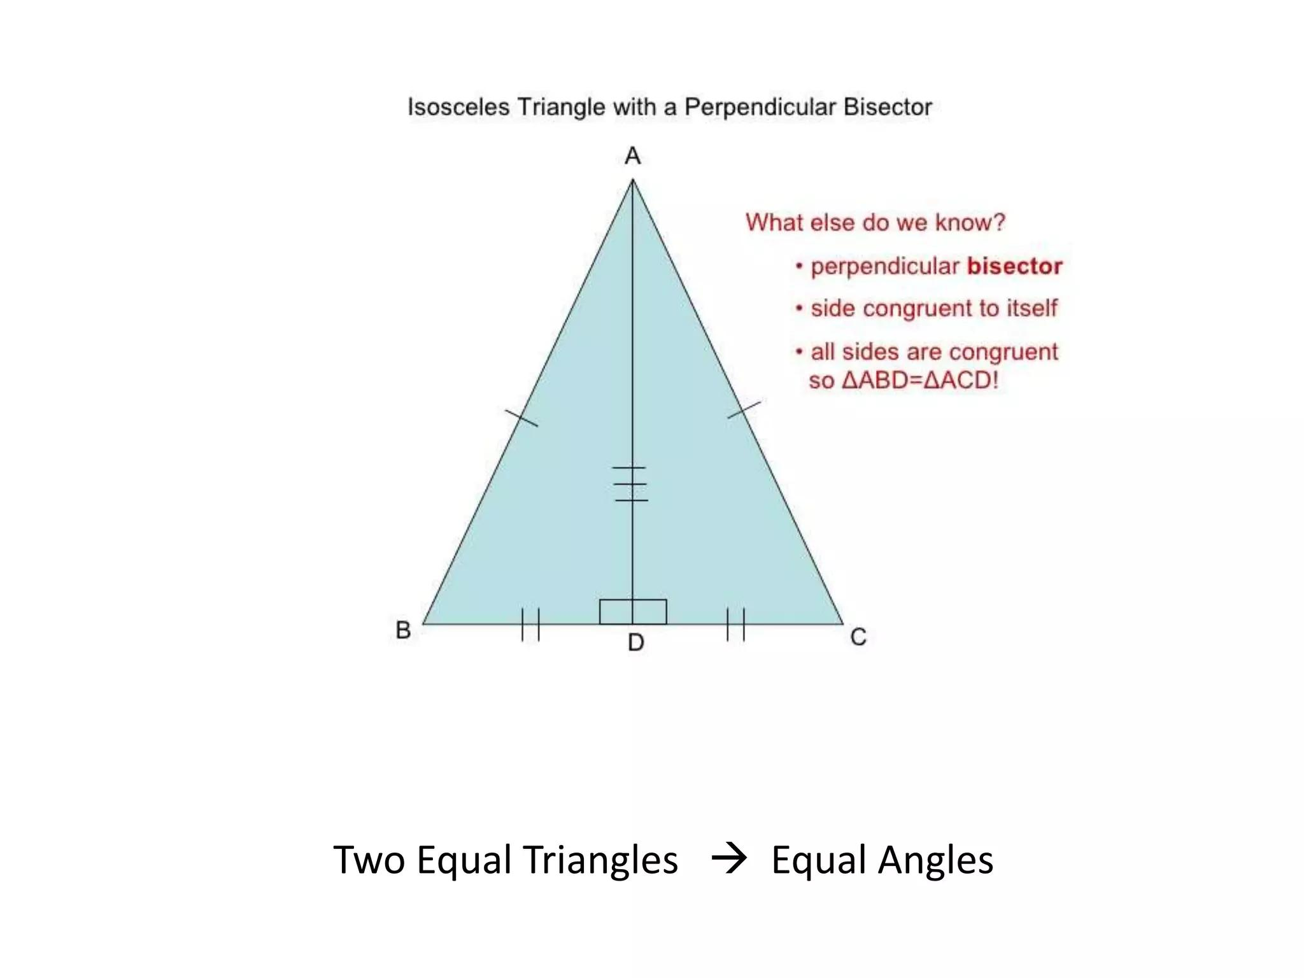
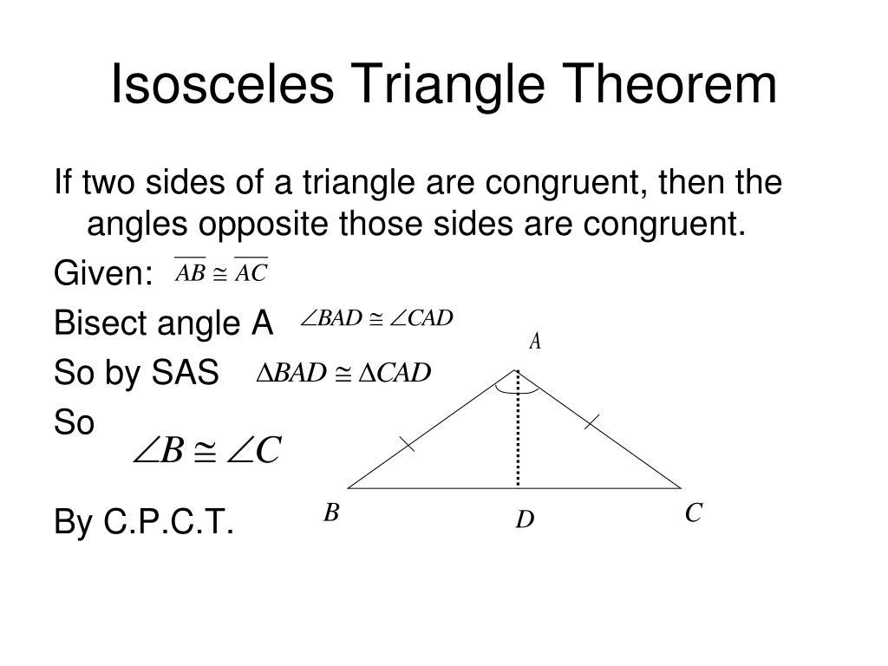

Real-World Applications
# Source: AI Source: Provided by: [Data Path: Persons Table -> ID Column: 1, Name_En Column: Motasem Essam] -> From: [ChatGPT] on [7/25/2026]
The properties of isosceles triangles appear in:
- Architecture.
- Roof structures.
- Bridge construction.
- Structural engineering.
- Mechanical design.
- Technical drawing.
- Computer graphics.
- Decorative designs.
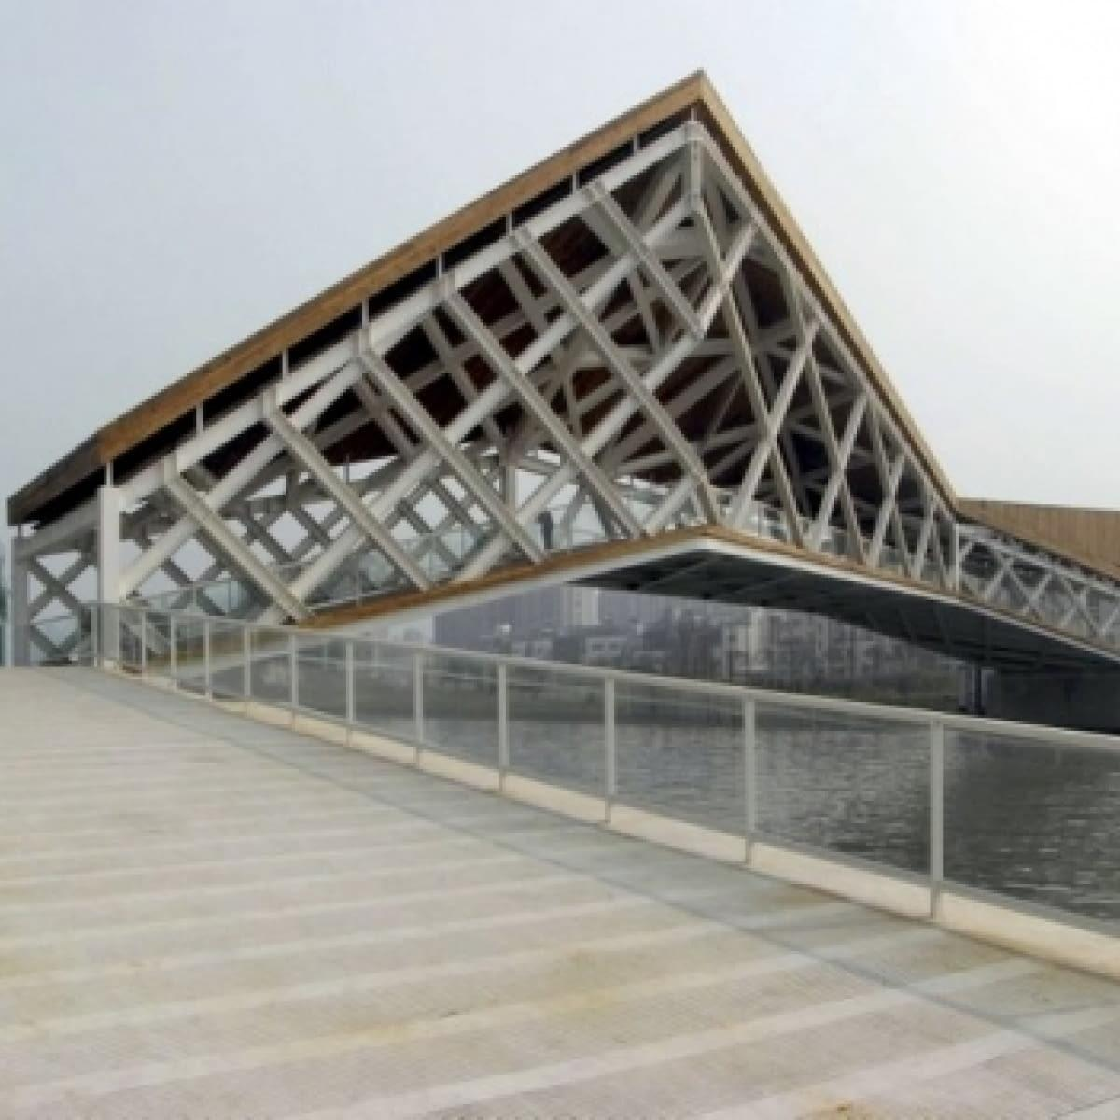
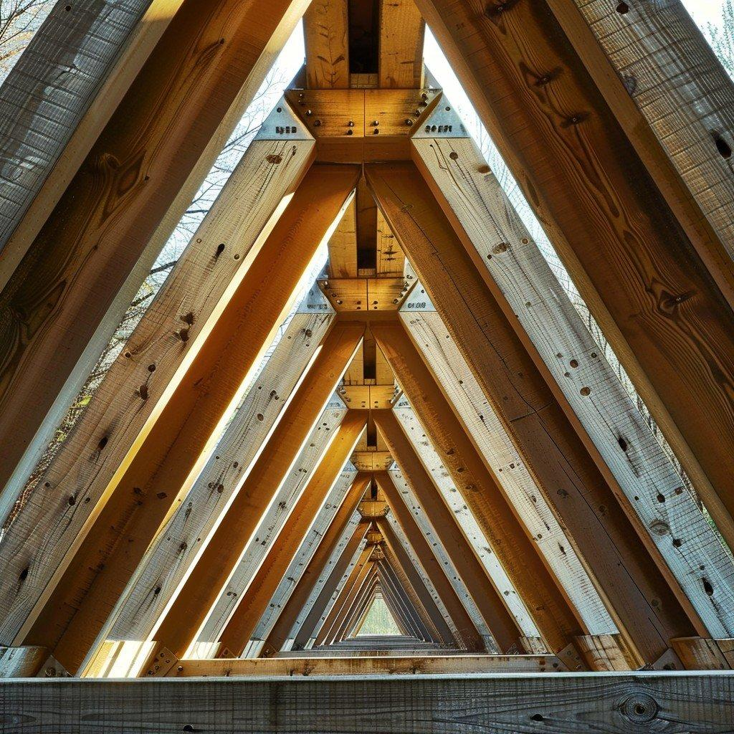
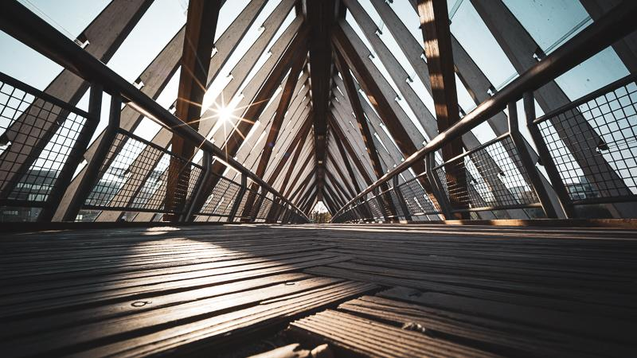
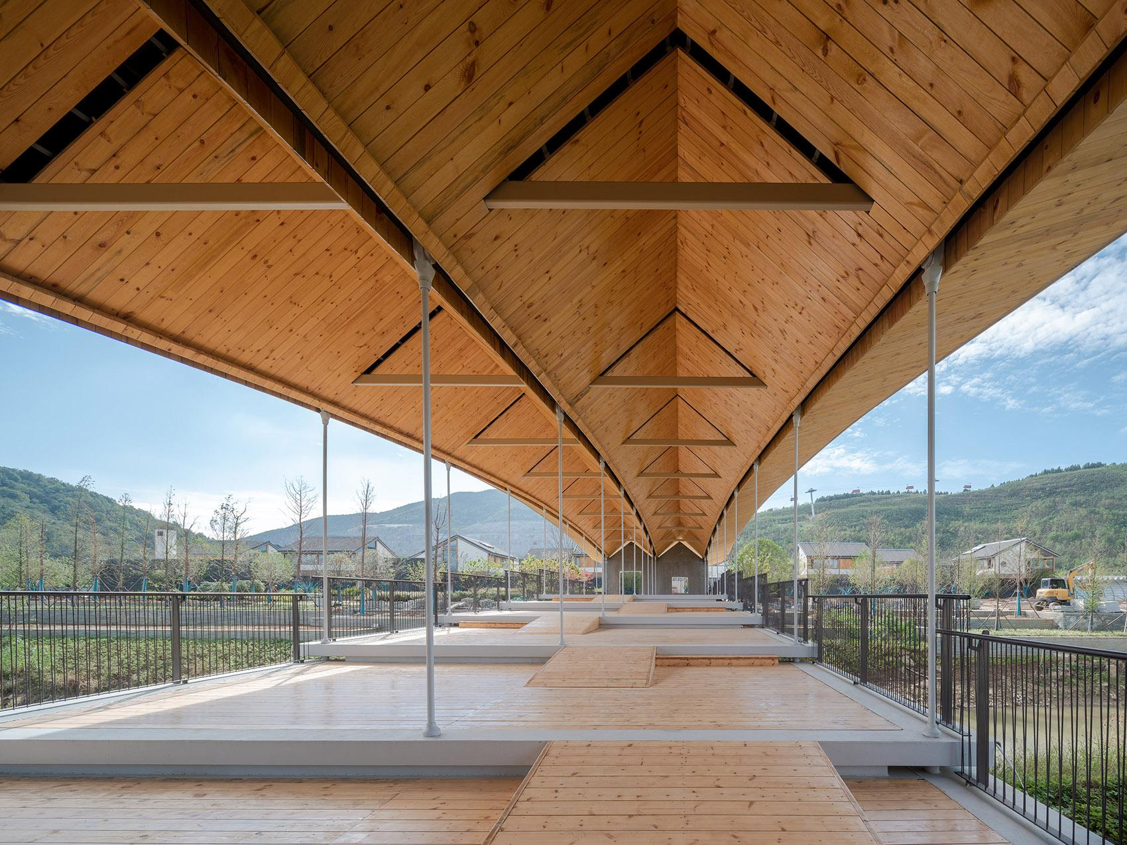
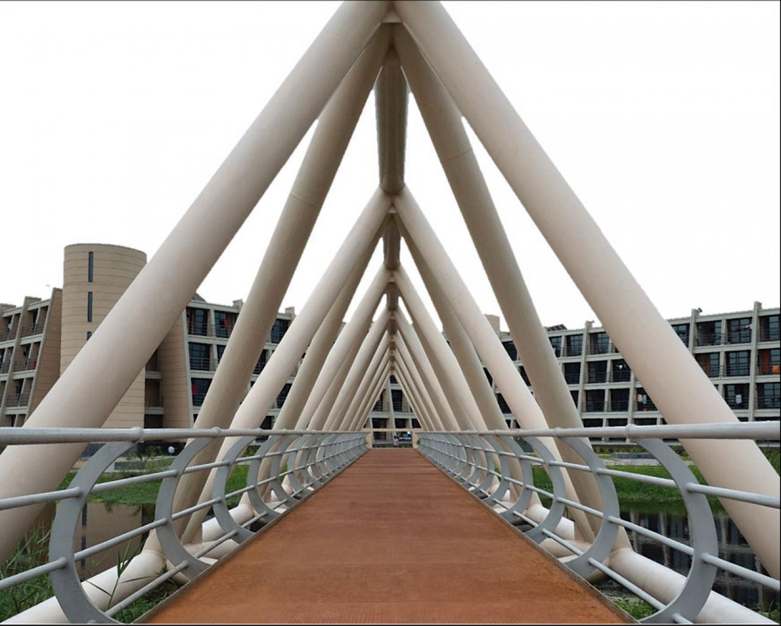
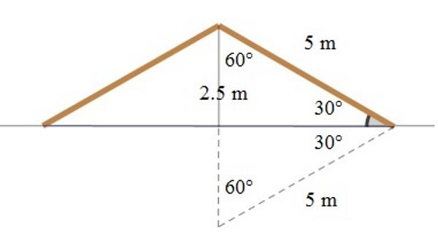

Applications
# Source: AI Source: Provided by: [Data Path: Persons Table -> ID Column: 1, Name_En Column: Motasem Essam] -> From: [ChatGPT] on [7/25/2026]
The theorem is important in:
- Plane Geometry
- Triangle Geometry
- Euclidean Geometry
- Triangle Congruence
- Triangle Similarity
- Trigonometry
- Architecture
- Engineering
- Construction
- CAD
- Computer Graphics

Advantages
# Source: AI Source: Provided by: [Data Path: Persons Table -> ID Column: 1, Name_En Column: Motasem Essam] -> From: [ChatGPT] on [7/25/2026]
The Isosceles Triangle Theorem helps to:
- Determine unknown angles.
- Identify equal angles.
- Identify isosceles triangles.
- Simplify geometric proofs.
- Establish triangle congruence.
- Solve construction and measurement problems.

Limitations
# Source: AI Source: Provided by: [Data Path: Persons Table -> ID Column: 1, Name_En Column: Motasem Essam] -> From: [ChatGPT] on [7/25/2026]
The theorem:
- Applies specifically to triangles.
- Requires two equal sides for the direct theorem.
- Requires two equal angles for the converse.
- Does not directly determine the lengths of unequal sides.
- Must correctly identify which angles are opposite the equal sides.

Comparison with Related Concepts
# Source: AI Source: Provided by: [Data Path: Persons Table -> ID Column: 1, Name_En Column: Motasem Essam] -> From: [ChatGPT] on [7/25/2026]
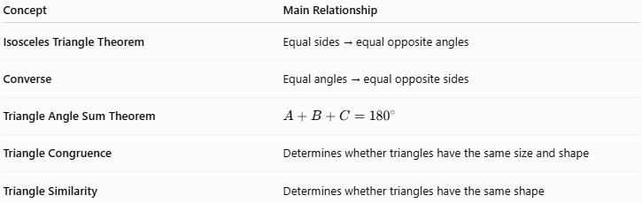
Concept | Main Relationship
Isosceles Triangle Theorem | Equal sides → equal opposite angles
Converse | Equal angles → equal opposite sides
Triangle Angle Sum Theorem | $$A+B+C={180}^{∘}$$
Triangle Congruence | Determines whether triangles have the same size and shape
Triangle Similarity | Determines whether triangles have the same shape

Key Points
# Source: AI Source: Provided by: [Data Path: Persons Table -> ID Column: 1, Name_En Column: Motasem Essam] -> From: [ChatGPT] on [7/25/2026]
- An isosceles triangle has at least two equal sides.
- The angles opposite the equal sides are equal.
- If:
$$\boxed{AB=AC}$$
then:
$$\boxed{∠B=∠C}$$
- The equal angles are called the base angles.
- The angle between the equal sides is called the vertex angle.
- The converse states:
$$\boxed{∠B=∠C⇒AB=AC}$$
- An equilateral triangle is a special case of an isosceles triangle when "isosceles" means at least two equal sides.
- The theorem works closely with the Triangle Angle Sum Theorem and triangle congruence.

Conclusion
# Source: AI Source: Provided by: [Data Path: Persons Table -> ID Column: 1, Name_En Column: Motasem Essam] -> From: [ChatGPT] on [7/25/2026]
The Isosceles Triangle Theorem states that if two sides of a triangle are equal, then the angles opposite those sides are also equal:
$$\boxed{AB=AC⇒∠B=∠C}$$
Its converse states that if two angles of a triangle are equal, then the sides opposite those angles are equal:
$$\boxed{∠B=∠C⇒AB=AC}$$
This theorem is fundamental to triangle geometry, congruence, similarity, geometric proofs, construction, architecture, and engineering, because it establishes a direct relationship between the side lengths and angle measures of a triangle.

